I would like your input to help me develop a plan to help you achieve YOUR Goals
Please take a few minutes and complete this form so I can use your information while developing your Private Training
_______________________________ Name _________ Age _______________________________Best Contact #
What would you like to accomplish in the next 30-60 days?_________________________________________________
__________________________________________________________________________________________________
(Example: reduce body fat, increase strength, improve agility, gain mobility, etc.. Be specific and detailed!)

What are your ultimate fitness or health goals? __________________________________________________________
__________________________________________________________________________________________________
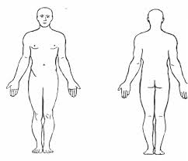

What do you feel are your quickest developing areas? (use O)
What do you feel need the most improvement? (use X)

What exercises and workouts do you enjoy most? __________________________________________________________________________________________________
What workouts do you struggle with and dread the most? _________________________________________________
__________________________________________________________________________________________________
Do you prefer spontaneity or a routine that you can settle into? _____________________________________________
__________________________________________________________________________________________________
What additional support do you think would benefit you the most to achieve your short term and long term goals quicker? ___________________________________________________________________________________________
__________________________________________________________________________________________________
Are there any environmental constraints, obstacles, interference's, or speed bumps that get in the way of you achieving your fitness goal(s) _________________________________________________________________________
__________________________________________________________________________________________________

